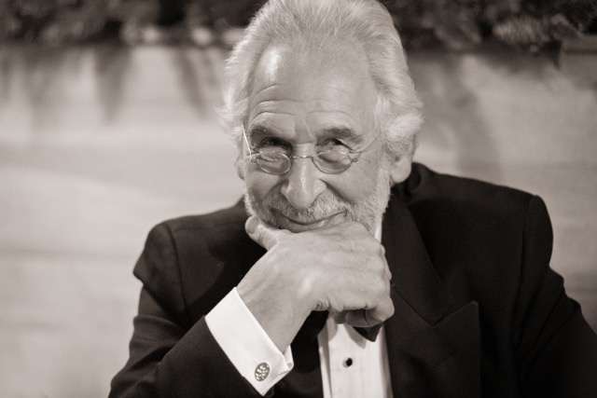
“The measure of your youth is the number of dreams that you have”
Shimon Peres
“I haven’t been everywhere, but it’s on my list”
Susan Sontag
“When you stop learning you start dying”
Albert Einstein

BIOGRAPHICAL NOTE

PAUL JOSEPH DANIELS

Mobile: 07836 237639 Office: 01342 843311 Email: pjd@omf.uk.com
Website: www.involvedinvestors.com

Over 55 years in business Paul Daniels has led 36 M&A deals and investments. He has started and developed 10 companies in sectors including food, marketing and media, traffic management, property, construction and self-storage and has masterminded 14 exits at multiples up to 26x price/earnings.

Paul attributes his success to the excellent people he has gathered around him and regards trust and respect as being the two essential ingredients in team building.

Paul’s key skills are chairmanship, deal making, mentoring and empowering good ideas and bright people to succeed.

Paul Daniels was born during the Blitz in London in 1943 and attended a preparatory boarding school in Surrey, where he acquired a great love of the countryside. His education continued at Aldenham School in Hertfordshire, the London Polytechnic (now Westminster University) and London Business School.

Paul invests in early stage companies, assisting and mentoring them in developing viable and sustainable business models. He typically helps set them up for future growth, at which time he prefers to handover to others to maintain and develop the businesses, devoting his skills to fresh ventures.

Paul joined the family business, S Daniels & Co Ltd in 1965 and was appointed Managing Director in 1973 and Chairman & CEO in 1986, when the company floated on the main list of the London Stock Exchange. Between 1993 and 1995 he and his team refocused the group into value added chilled food, including the acquisitions of New Covent Garden Soup, Johnsons Orange Juice and others. The company was sold to Singapore Foods Ltd and after various iterations and is now Hain Daniels, the European arm of Hain Celestial (US).

Paul embarked on a second career with a younger Dutch partner and together they founded 6 Start-ups across diverse sectors including traffic management, outdoor media, self-storage and construction of key worker homes and car parking decks. Each company had one thing in common – break through innovation. Paul and his partner successfully exited 5 of these, retaining one.

Paul also invests in many early stage companies spanning a range of industrial sectors including micro-breweries, cancer therapeutics, industrial kitchens, marketing data systems, call centre security and mortgage platforms, where he has offered his support and advice, and in many cases, raised funds on their behalf. He has been adding new investments on a monthly basis.

Paul invested, at an early stage, in Graze (Nature Delivered) – snack foods initially sold e-retail and then retail in the UK and USA. He was Octopus VCs Board Monitor as well as Chairman of the Food Advisory Board and the company was sold to Carlyle Group US Global Asset Management in 2012 and subsequently to Unilever in early 2019. Paul was also Chairman of Angel Investment Network Ltd (AIN) the largest Angel network in the world, spanning over 83 countries, in its formative years.

Other early stage investments included Vega-Chi Ltd, for whom he also raised funds – this was Europe’s first electronic multi-lateral trading facility dedicated to convertible and high yield OGC Bonds and was sold to Liquidnet of the USA in 2014. In 2013 Paul joined the Board of Money & Co (Denmark Square Ltd) – a crowd lending platform to business, which he chaired. He was a seed investor in Tails.com the subscription based e-retailer providing bespoke dog food delivered straight to the door, sold to Nestle, and also WeSwap.com, the world’s first social currency platform enabling travellers to swap currency directly with each other – where his company, Involved Investors* raised considerable early stage funds. More recent investments and fund raises have included PSYT – mindfulness technology platform, SNPT – an influencer platform and Paul also assisted in the sale of companies in association with the world’s largest SME brokers.

Paul Daniels is a Freeman of the City of London, a Liveryman in the Honourable Company of Basket Makers, a member of the Institute of Directors and the Royal Automobile Club, a Fellow of the Royal Society of Arts and Royal Geographical Society. He is Branch Chairman of the Royal British Legion and his charitable activities include Kenya, UK National and village charities. He enjoys cycling, swimming, skiing, sailing and rugby spectating and his interests are sculpture, theatre, reading, politics, and horse racing.

Paul is the ‘resident’ Institute of Directors’ Dragon and a Judge on their annual ‘Director of the Year Awards’.

More detail of his commercial activities and his umbrella company, Involved Investors Ltd, can be found at www.involvedinvestors.com and also on Linkedin. * Please note that Involved Investors Ltd is a small management company. All investments in introductions by the company are made by Paul and his wife personally.

Last updated Jan 2020

